**University of Petroleum and Energy Studies** School of Computer Science

Department of Cybernetics



**GRAPHICS AND ANIMATION TOOLS LAB FILE**

*(Session: 2020-2021)*

**

Submitted To- Submitted By Dr. Durgansh Sharma Udit Krishna Chaudhary Assistant Professor Roll No. - 97 Department of Cybernetics SAP ID -500062348

**Task 1- Create any Mountain Range with Snowfall over it using GIMP**

1. Open GIMP, create a new layer with white background.

2. Open an image of the mountain as layers in GIMP and create a new transparent layer to draw boundaries.

3. Use the ‘Paths tool’ over the image and start selecting boundaries and layout of the image.

4. After selection of layout/ boundaries, go to ‘Select’, choose the ‘From Path’ option and your path will be selected.

5. After the path is selected click on ‘bucket fill tool’ from the toolbar and colour the mountain with your desired colour.

6. Repeat step 3,4,5 for creating the grass and sky of the scene. 7. Structure of the mountain scene is complete.

8. Use your creativity to style the snow cap and when you feel it’s good, then place it at the top of the mountain range.

9. For adding snowfall effect, add a new layer of black colour over all the layers and set the photo effect from normal to screen.

10. Go to Filters -> Noise -> RGB Noise and then press ‘OK’, this will add some noise to the image and make it translucent.

11.Again, Go to Filters -> Blur -> Pixelated and then press ‘OK’, this will make the noise effect pixelated.

12.Then, Go to Filters -> Blur -> Motion Blur and then press ‘OK’. 13.After completing the above steps, Go to Colors -> Levels and adjust the white and black input levels till you find a pixelated snow effect over your image.

14.Remove the extra layers.

**OUTPUT**

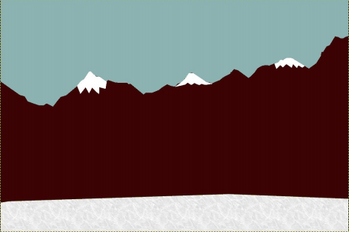

**Task 2- Create any City or Skyscraper using Blender**

1. Create a new project and clear out the screen , i.e. , remove the default cube. 2. Start with adding a plane to act as the base.

3. Now, add a cube and scale it to look like a cuboid(main structure of the building).

4. Now, take a plane and scale it and position it on one of the sides of the base cube(to represent windows).

5. Set the surface of the plane representing windows to Glass BSDF to give a glass like effect.

6. Add the plane representing windows as per the size of the base cube. 7. Do the same as in step 5 to all the sides of the cube.

8. Now choose a front side of the building, make another plane and scale and fix it at the bottom of the base cube representing the door of the building. 9. Fill colors in all the shapes as per your choice.

**OUTPUT**

